ENROLLMENT
G.H.S Sindhi Jamaat Co-Operative Housing Society
SEMIS CODE # 408170153
OLD Admission Year 2021
Class | Boys | Girls | Total
E.C | 10 | 8 | 18
I | 26 | 21 | 47
II | 15 | 10 | 25
III | 12 | 15 | 27
IV | 16 | 7 | 23
V | 11 | 8 | 19
Total | 90 | 69 | 159
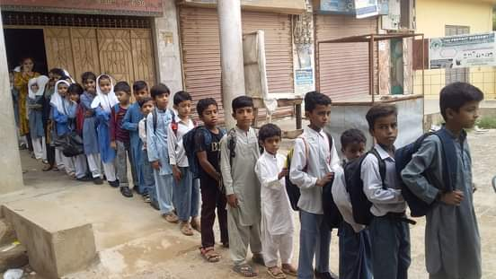
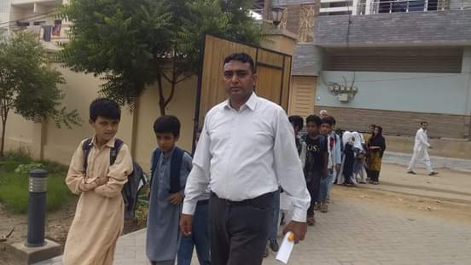
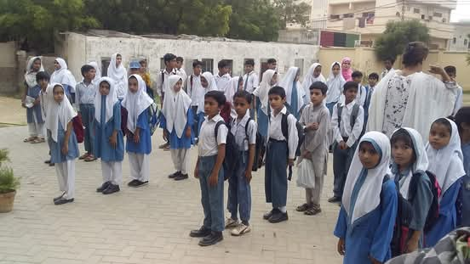
1st Day in the New Building (04-Aug-2022)
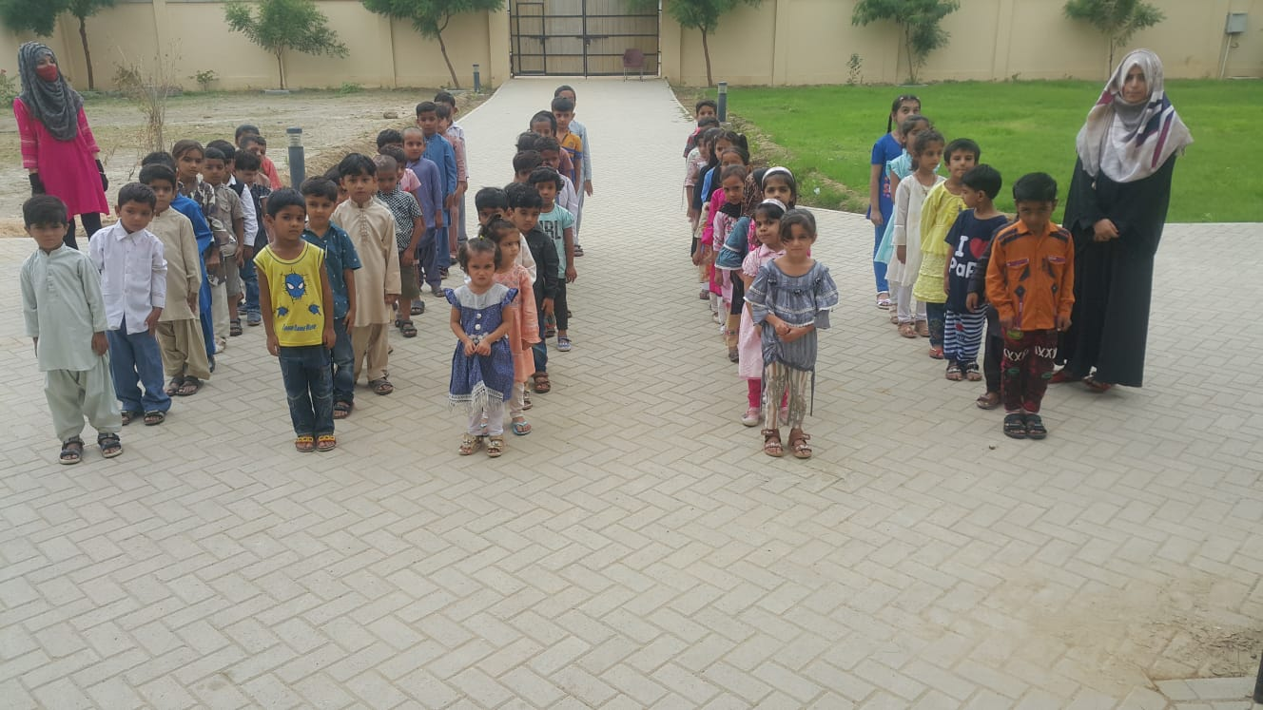
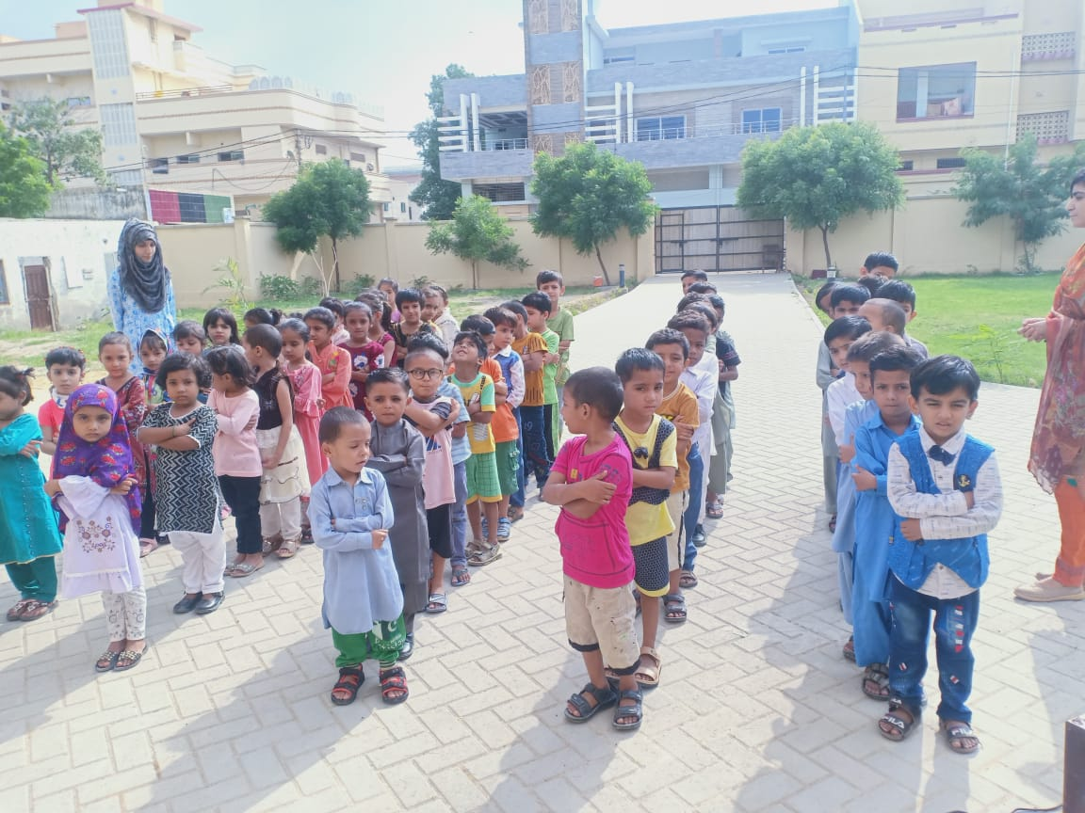

1st E.C Assembly (04-Aug-2022)

NEW Admission Year 2022
Class | Boys | Girls | Total
E.C | 40 | 36 | 76
I | 17 | 16 | 33
II | 15 | 23 | 38
III | 20 | 17 | 37
IV | 19 | 20 | 39
V | 23 | 12 | 35
Total | 134 | 124 | 258
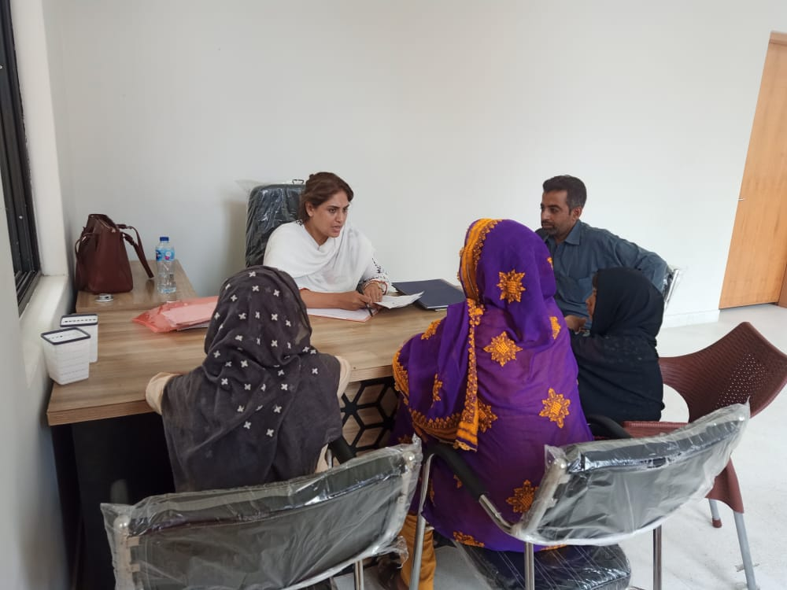
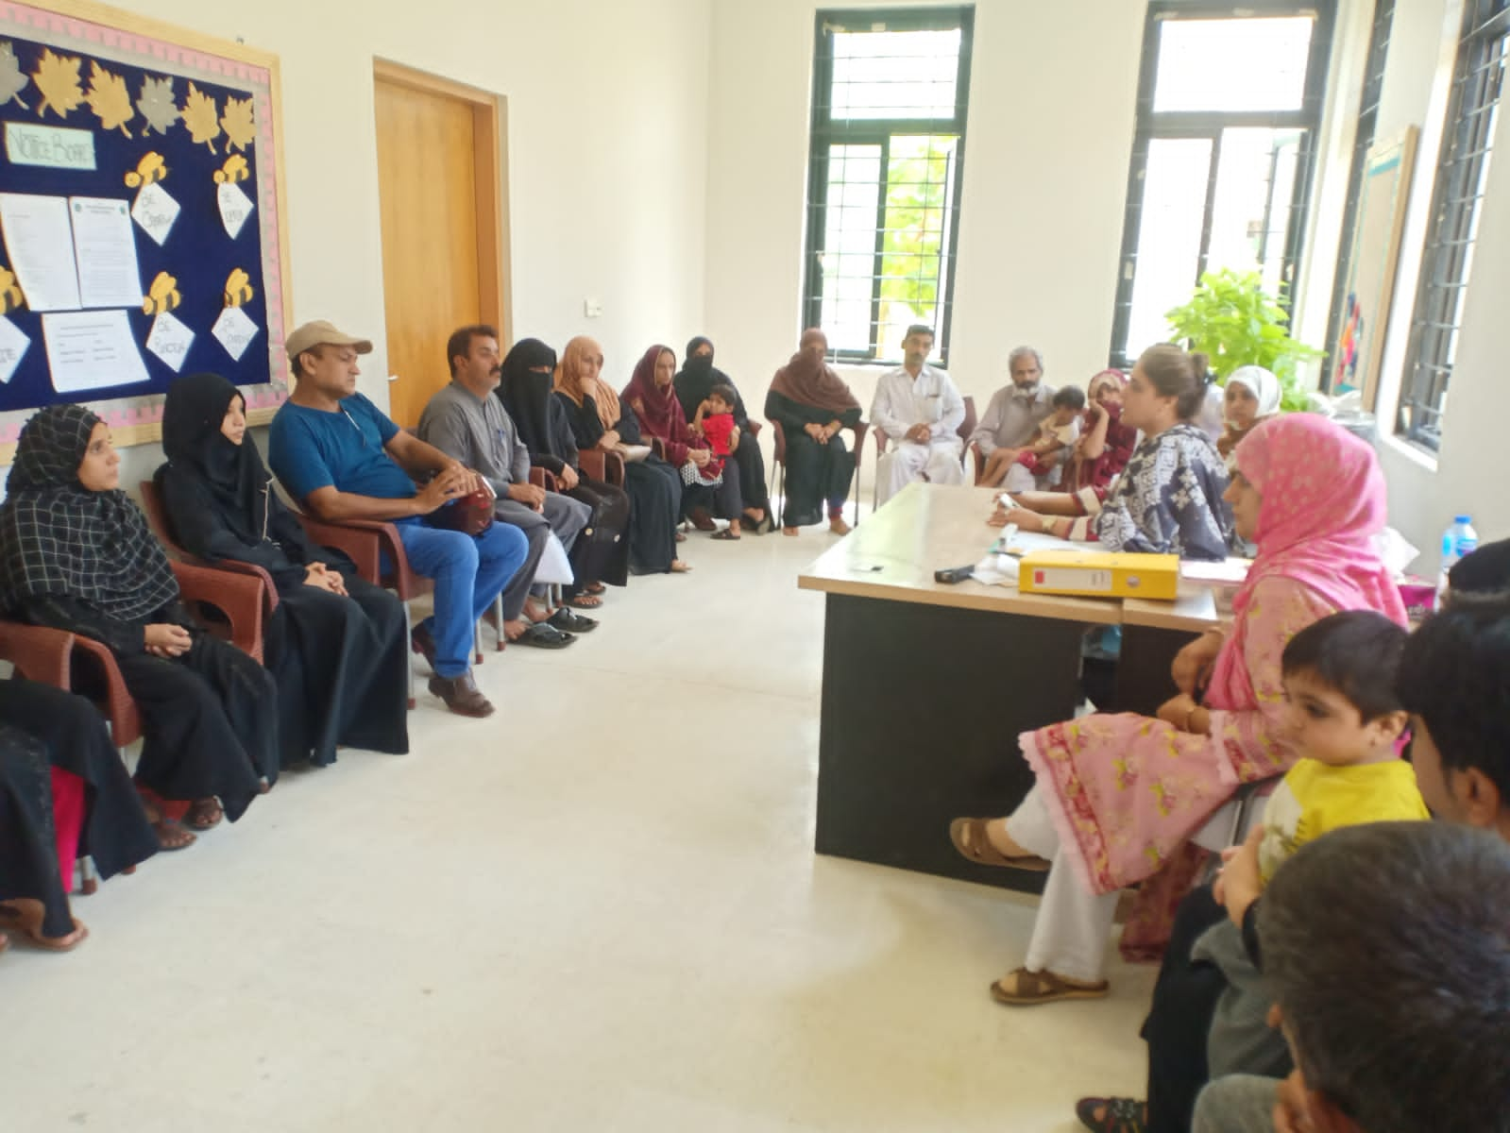
E.C Admissions (01-Aug-2022)

Total Enrollment in Year 2024-25
Class | Boys | Girls | Total
E.C | 62 | 48 | 110
I | 32 | 24 | 56
II | 26 | 26 | 52
III | 28 | 24 | 52
IV | 22 | 30 | 52
V | 23 | 23 | 46
VI | 17 | 25 | 42
VII | 27 | 19 | 46
VIII | 19 | 23 | 42
IX | 16 | 19 | 35
Total | 272 | 261 | 533
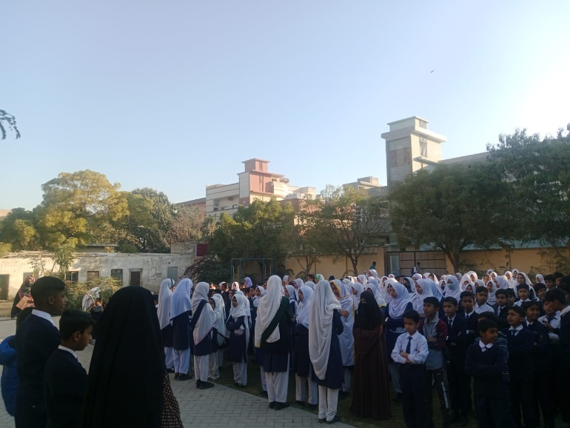
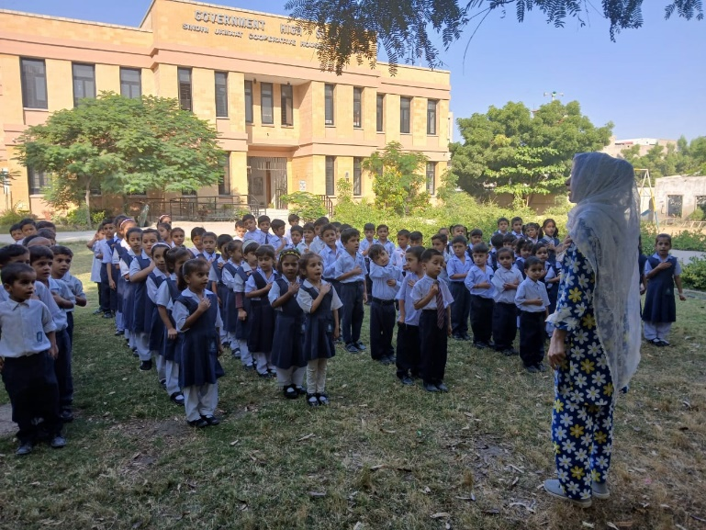
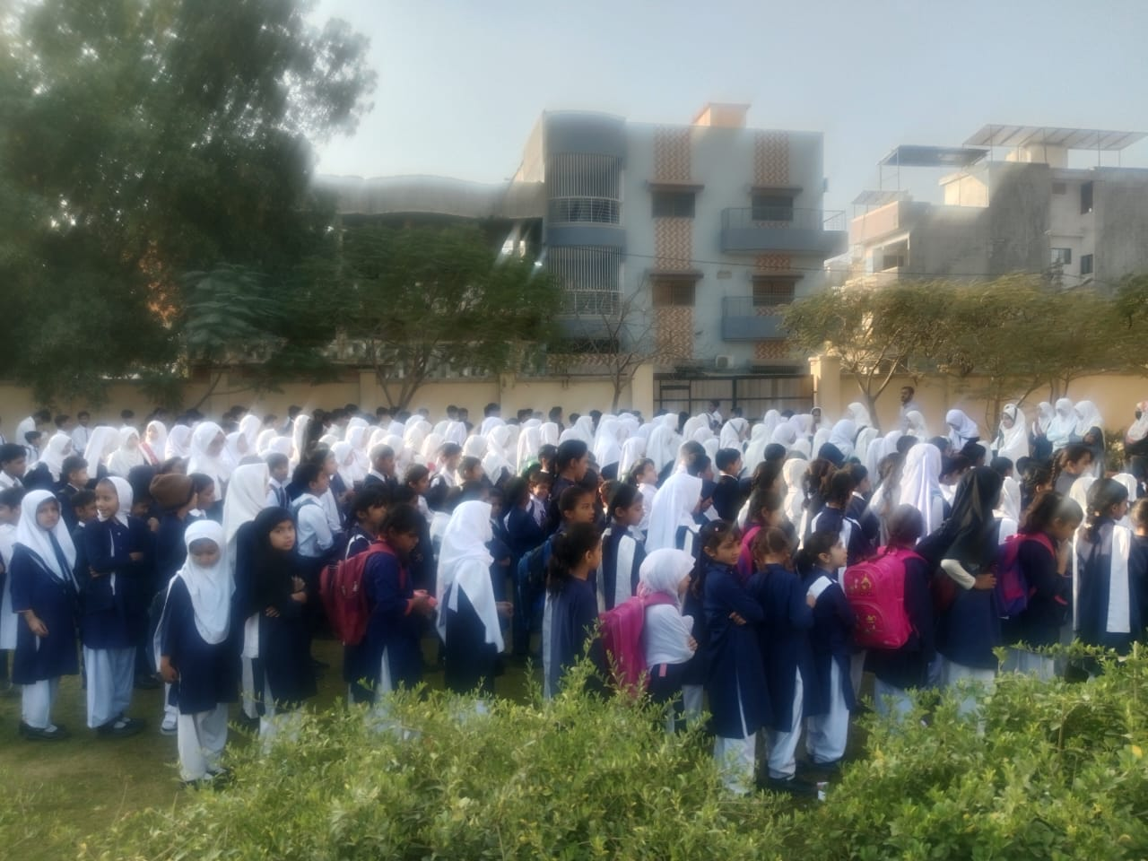
Till Now (12-Feb-2025)

Maintenance Plants and Walls (Year 2022)

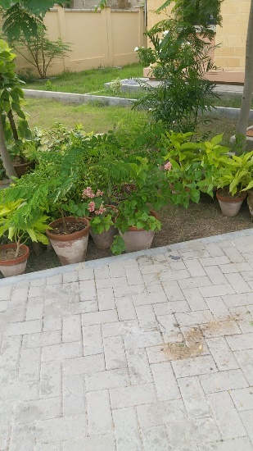
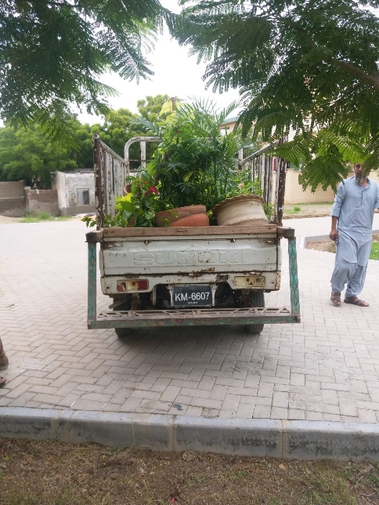
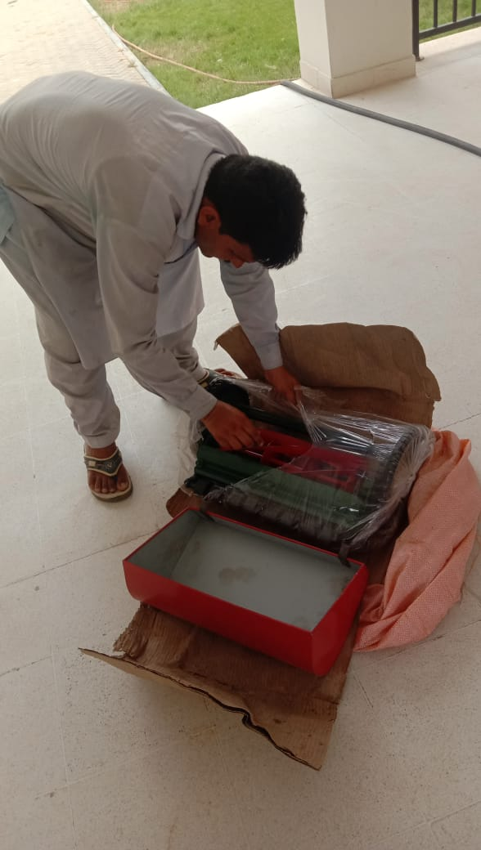
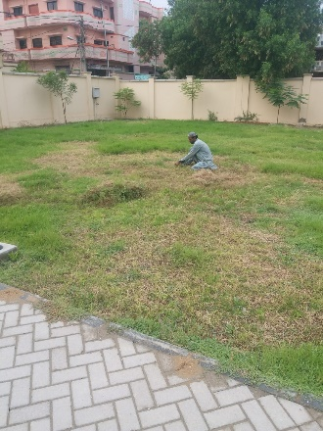
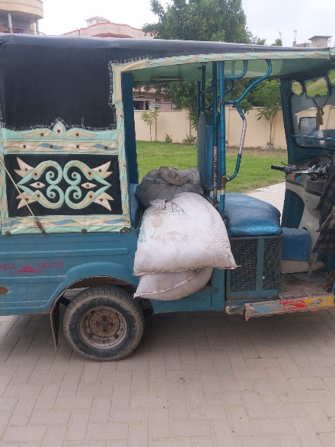
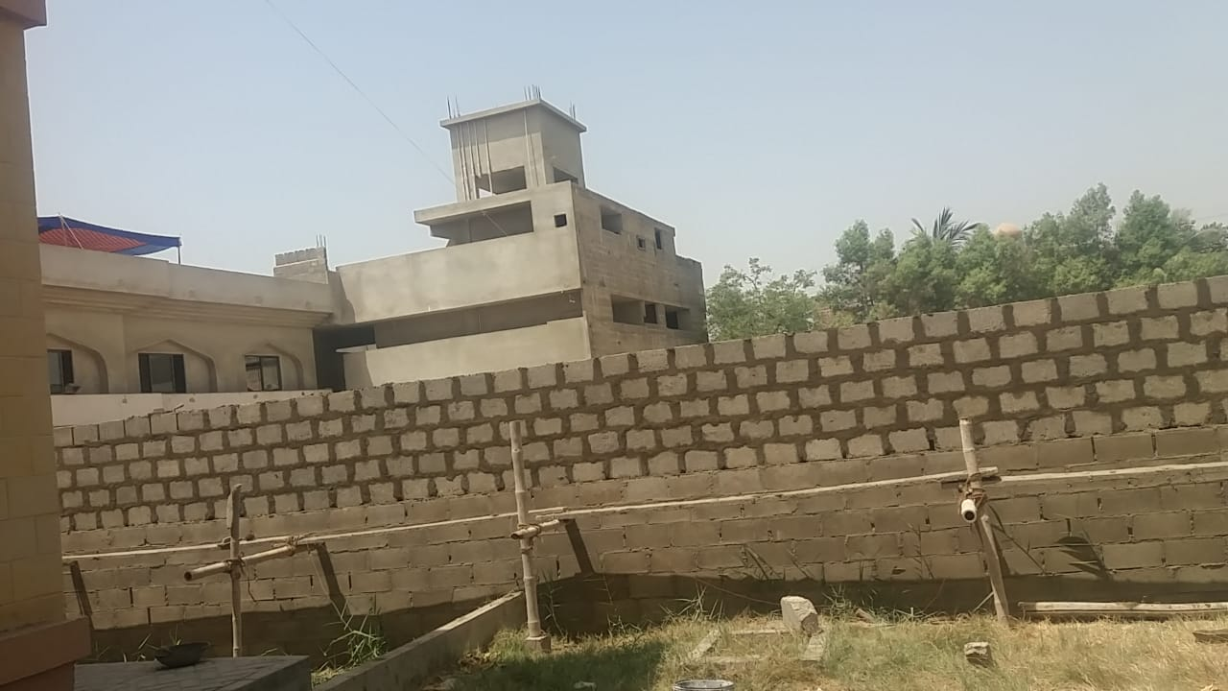
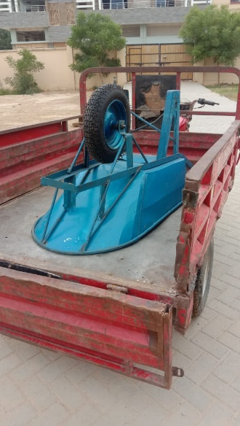
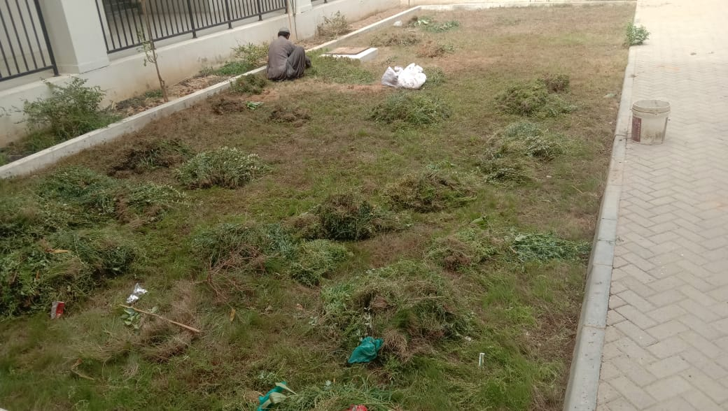
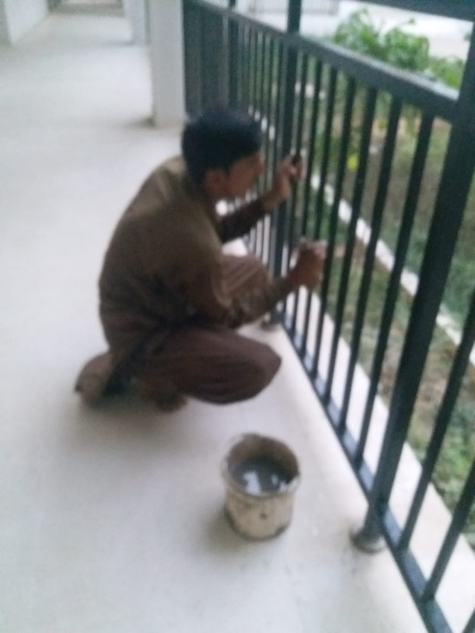
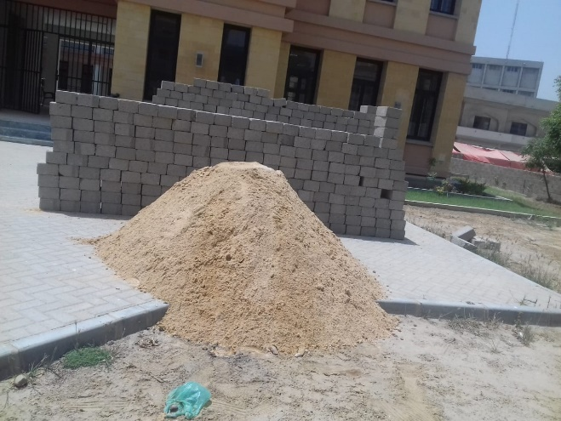

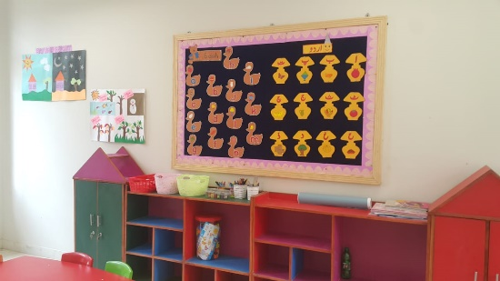
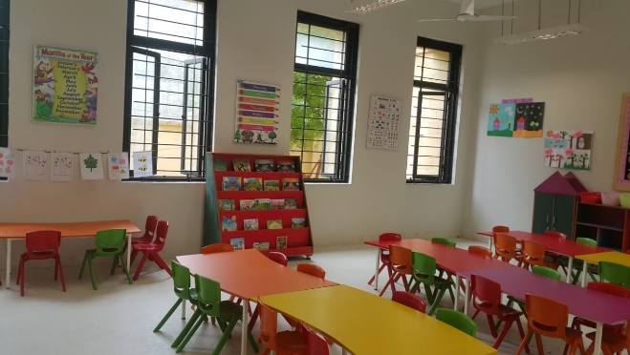
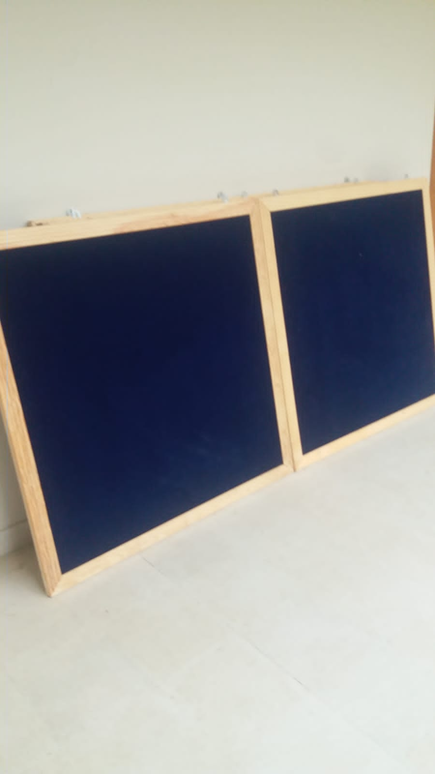
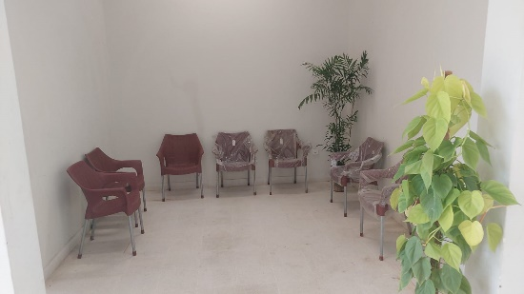
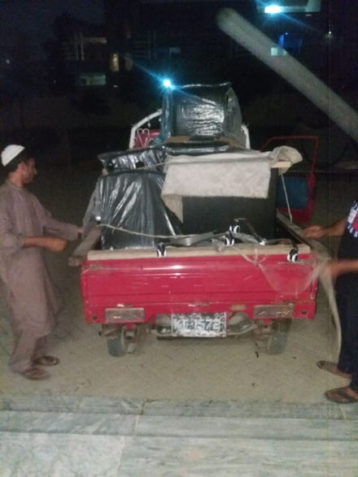
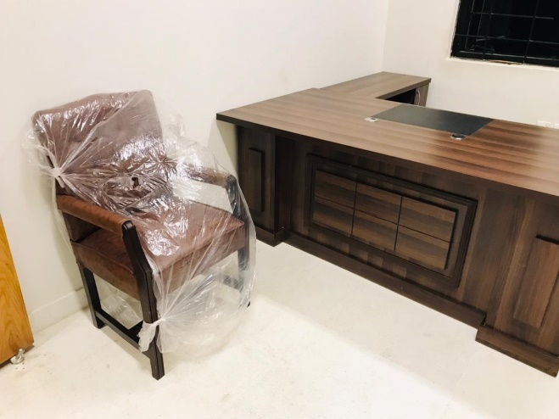
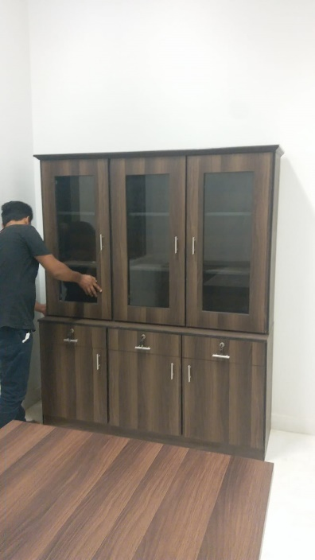
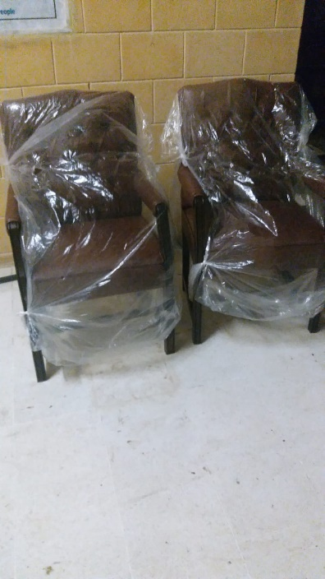
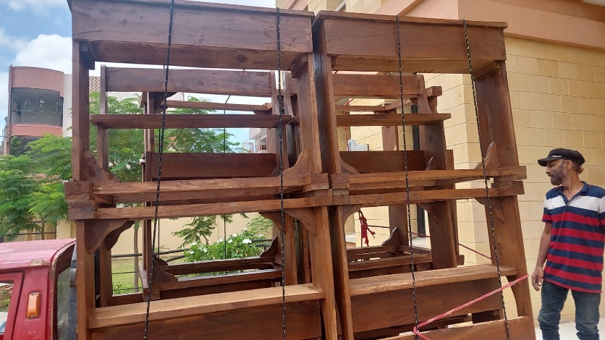
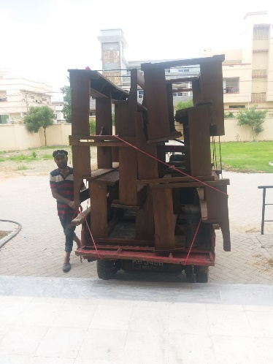
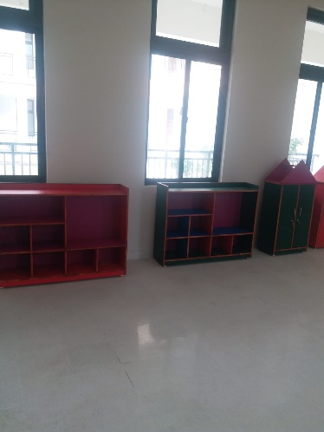
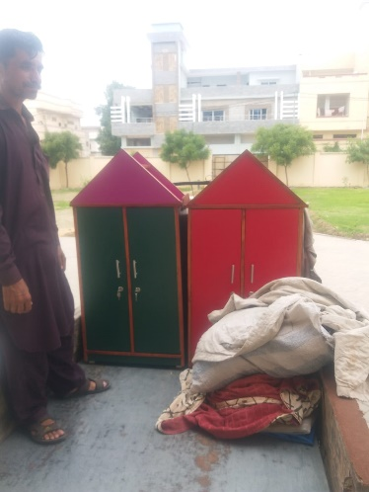
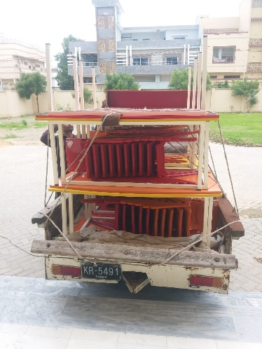
Furniture Provided by SMB (30-Jul-2022)
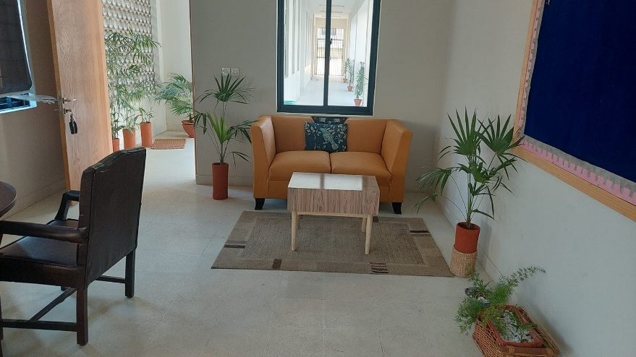
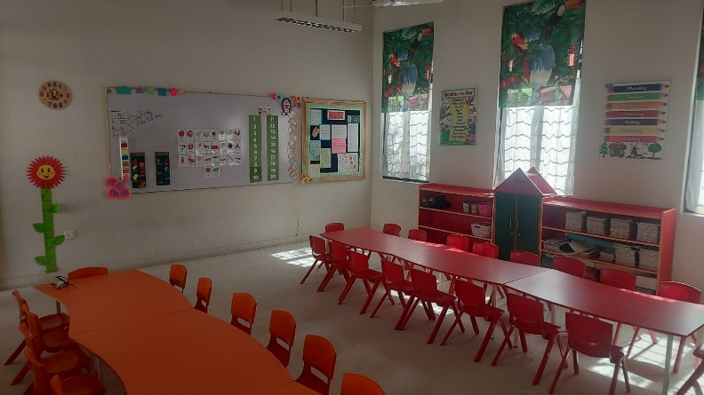
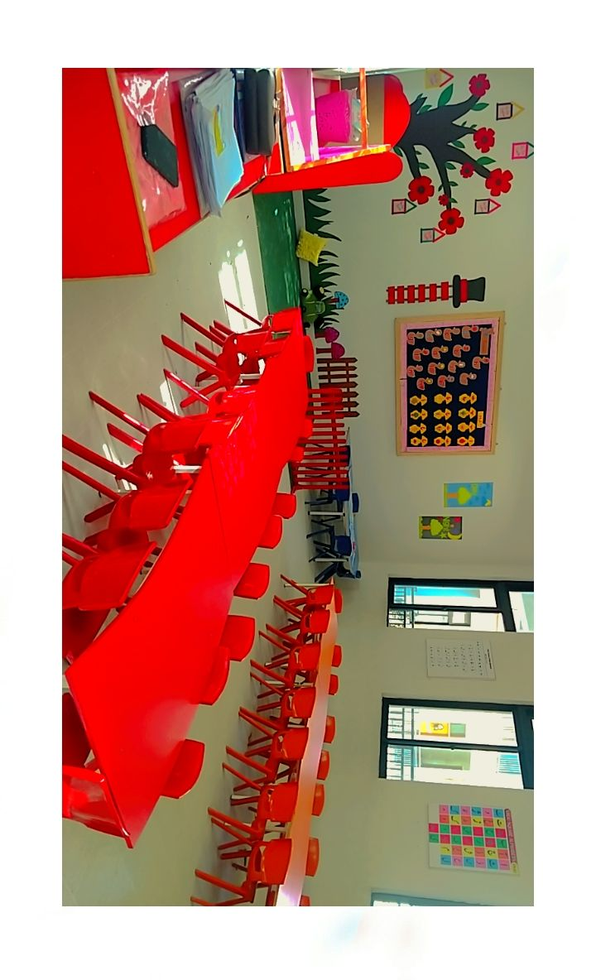
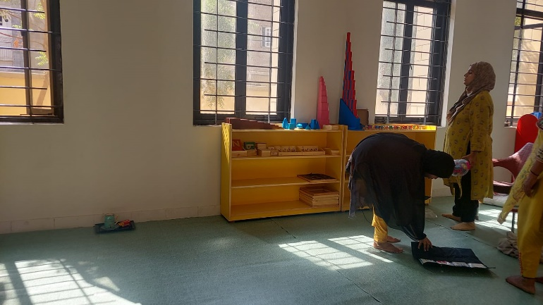
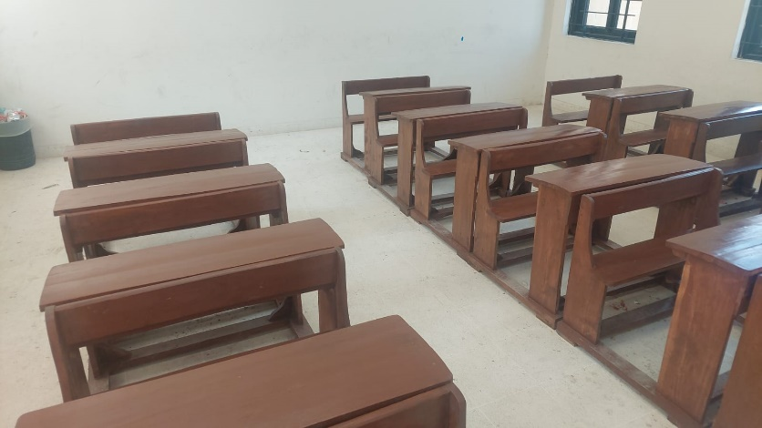
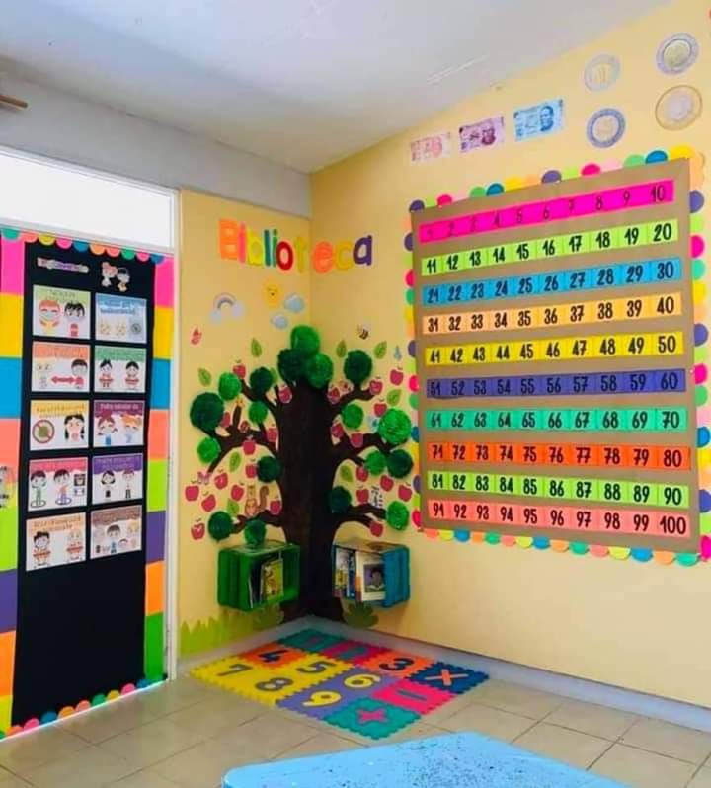
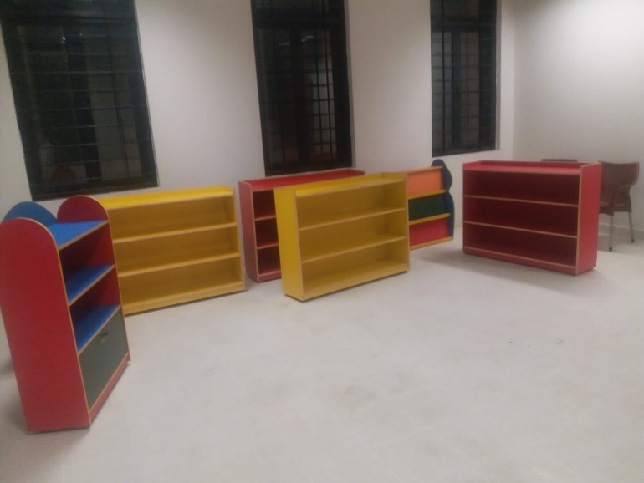
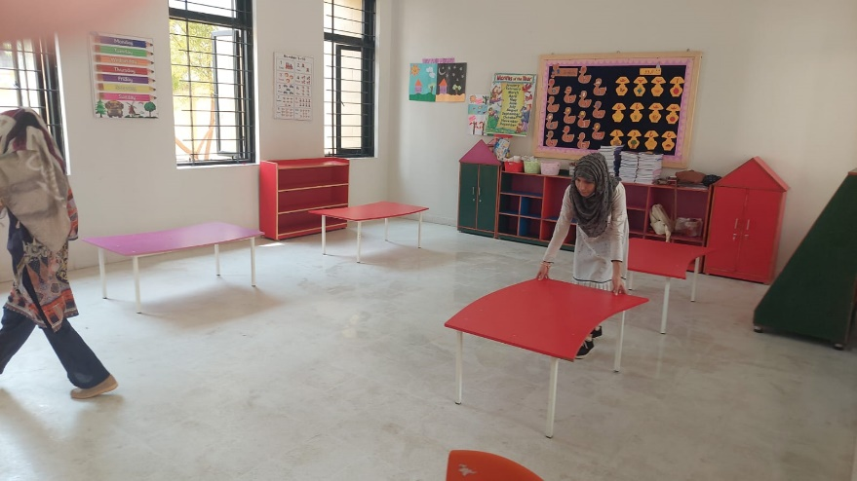
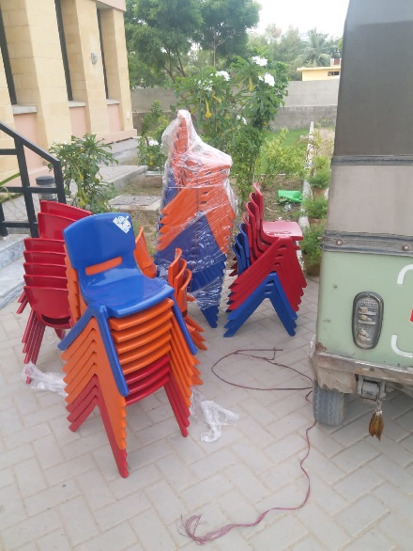
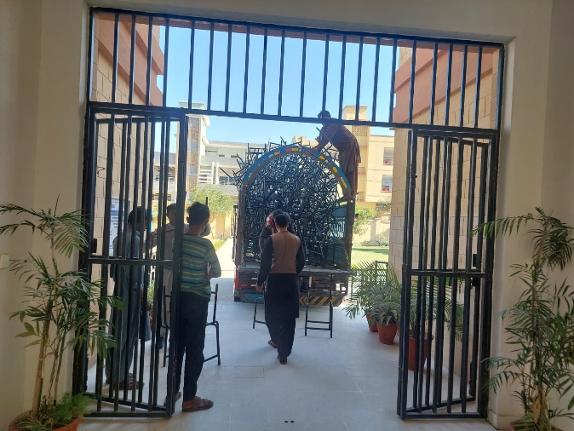
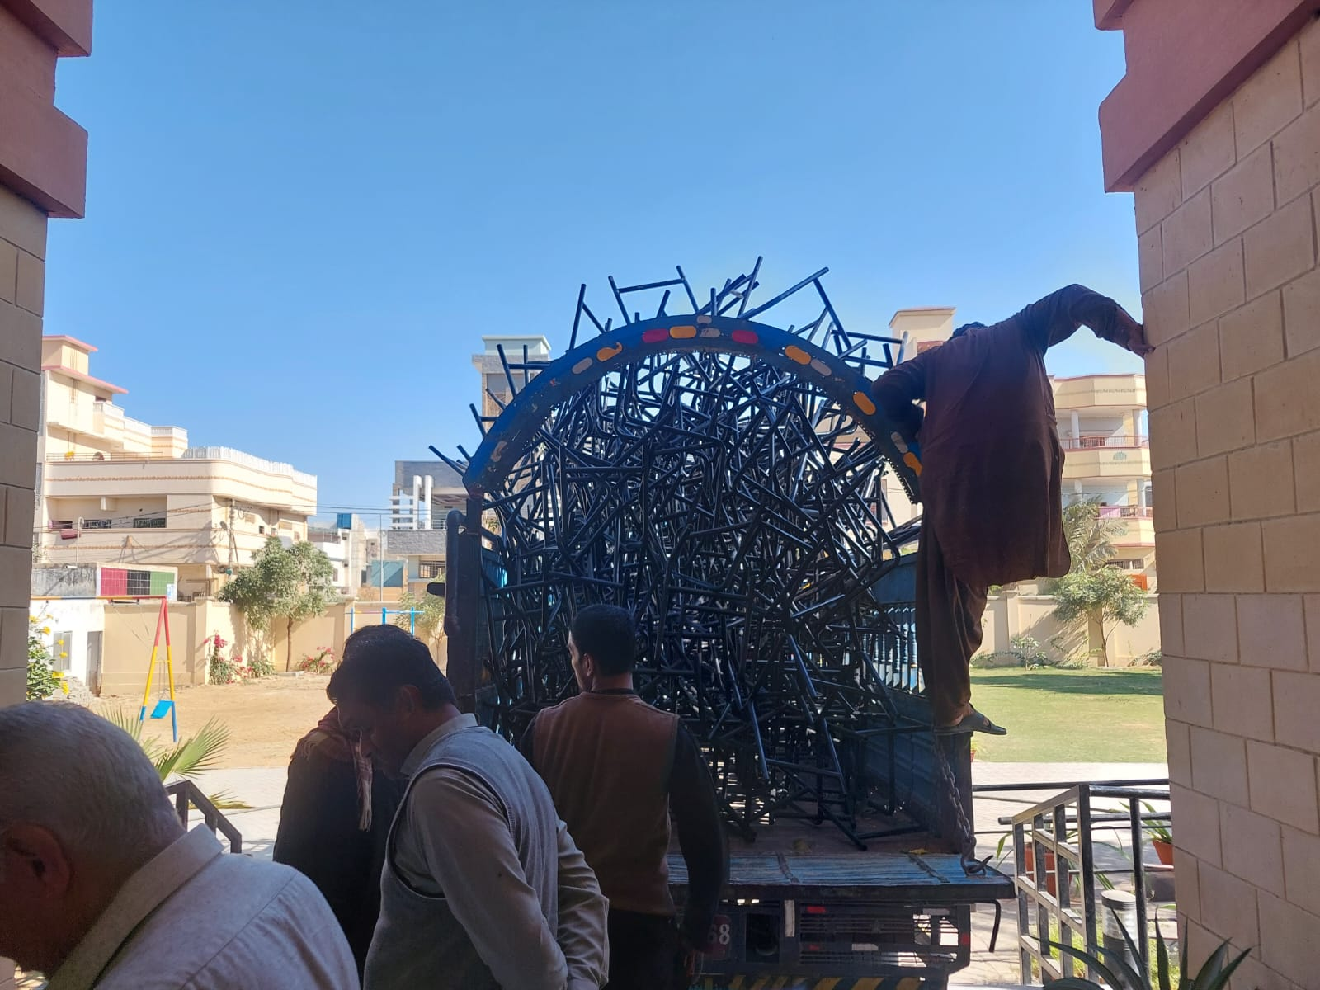
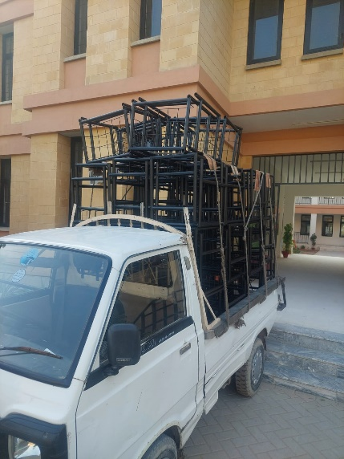
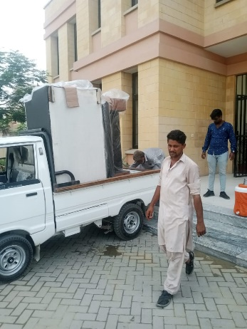
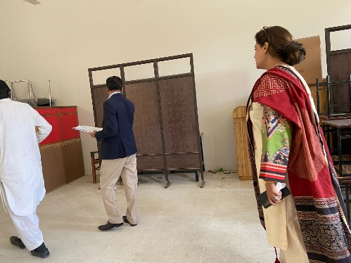
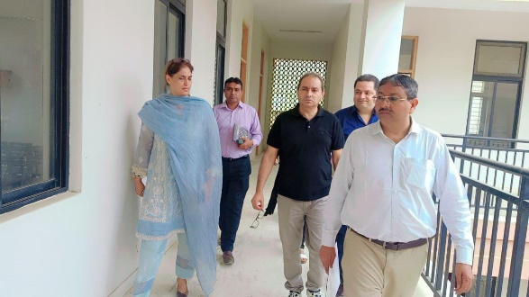
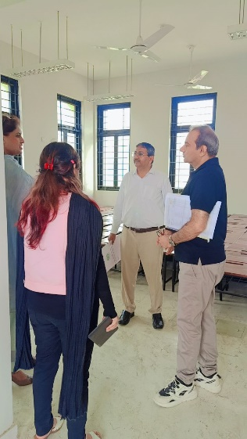
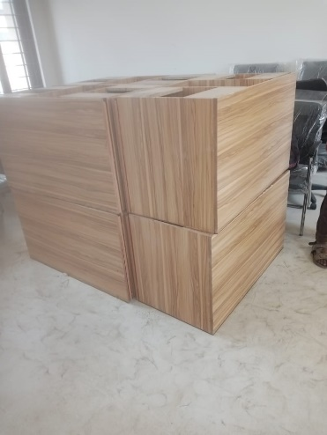
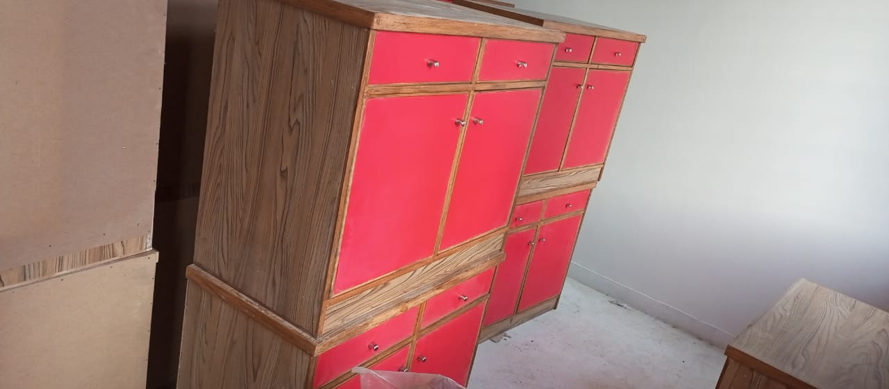
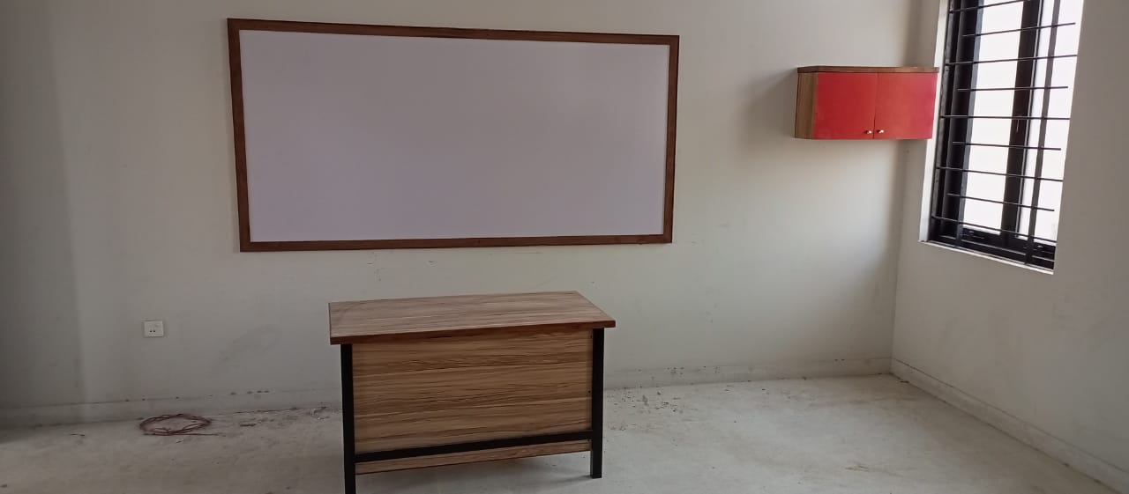
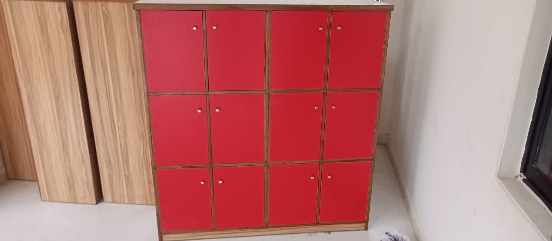
Furniture Provided by Govt. (15-Dec-2022)
SMB Staff Year 2022
S No | Name |  | Designation |  | Joining Date
1 | Syeda Samiya Kazmi |  | Co-Ordinator |  | 6-Oct-2021
2 | Shumaila |  | Directress |  | 1-Jul-2022
3 | Miss Saiqa |  | Teacher |  | 1-Aug-2022
4 | Shehzana |  | Teacher |  | 16-Aug-2022
5 | Tooba Mir |  | Trainee |  | 10-Aug-2022
6 | Saba |  | Trainee |  | 15-Aug-2022
Teaching SMB Staff Year 2025
1 |  | Miss Saiqa |  | Teacher |  | 1-Aug-2022
2 |  | Miss Saba |  | Teacher |  | 1-Feb-2024
3 |  | Parwish Fatima |  | Teacher |  | 1-Oct-2023
4 |  | Shehla Bhatti |  | Teacher |  | 20-Aug-2024
5 |  | Sir Fayyaz |  | IT Techer |  | 24-sep-2024
6 |  | Miss Hussan Bano |  | Directress |  | 1-Oct-2024
7 |  | Miss Tooba |  | Teacher |  | 10-Aug-2022
Teaching SMB Staff Year 2025
1 |  | Samiya Kazmi |  | Co-Ordinator |  | 6-Oct-2021
2 |  | Naeem Ahmed |  | Guard |  | 25-Jun-2024
3 |  | Ijaz Ahmed |  | Gardener |  | 1-Aug-2024
4 |  | Tahira Bibi |  | Maid |  | 10-Feb-2023
5 |  | Rimsha |  | Cleaner |  | 4-Feb-2023
6 |  | Haleema |  | Maid |  | 23-Oct-2024
7 |  | Nusrat |  | Maid |  | 1-Nov-2024

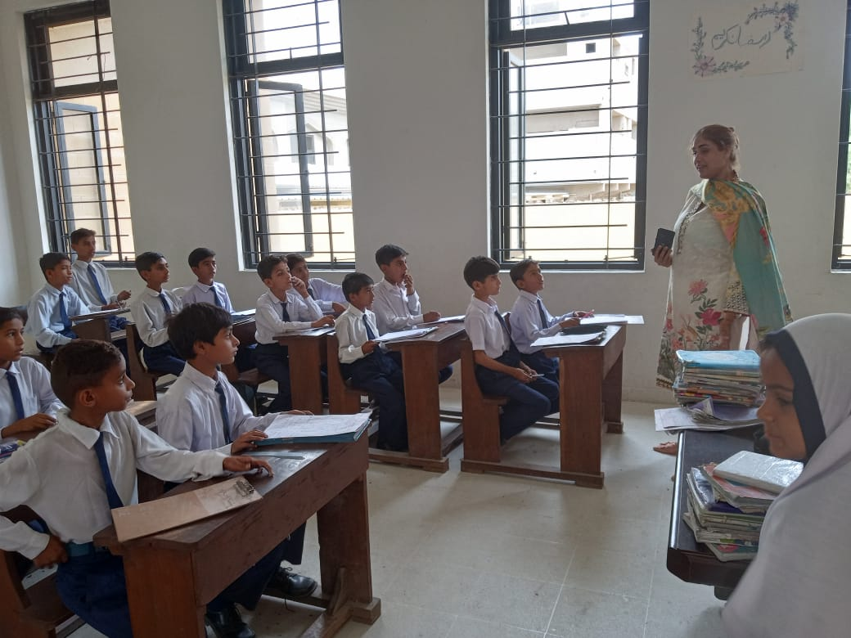
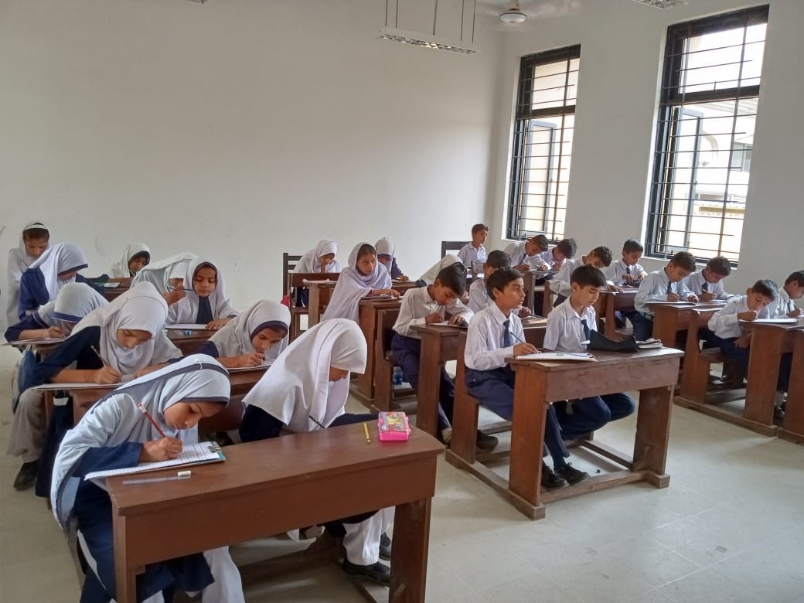
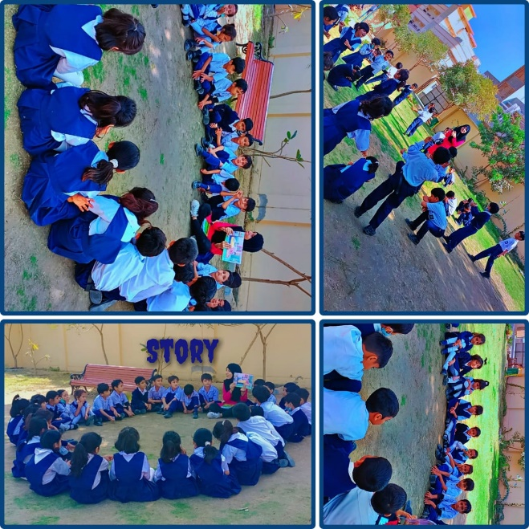
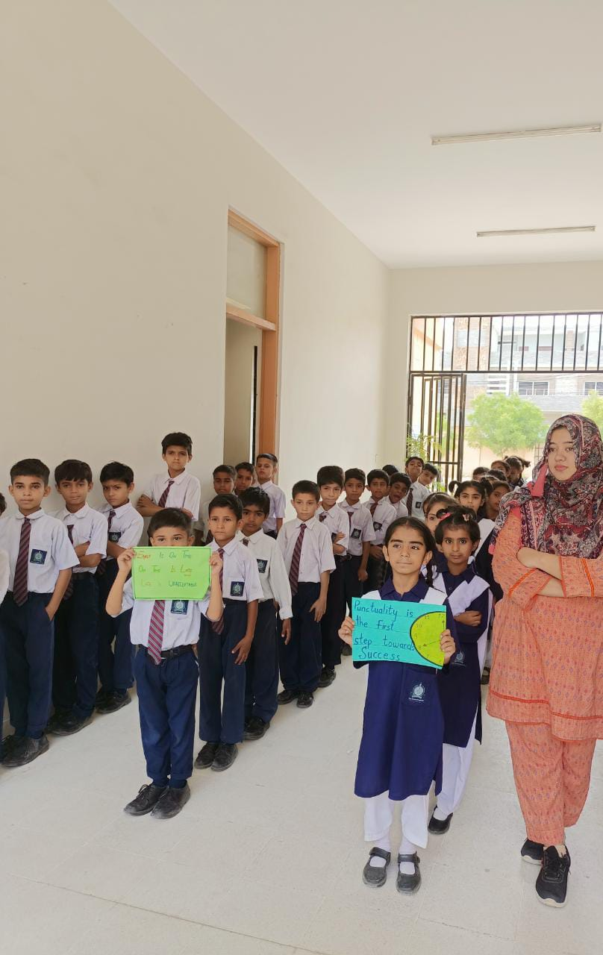
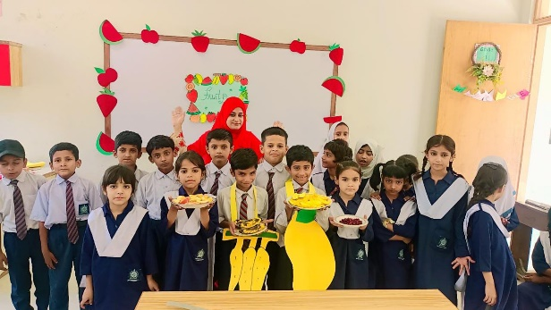
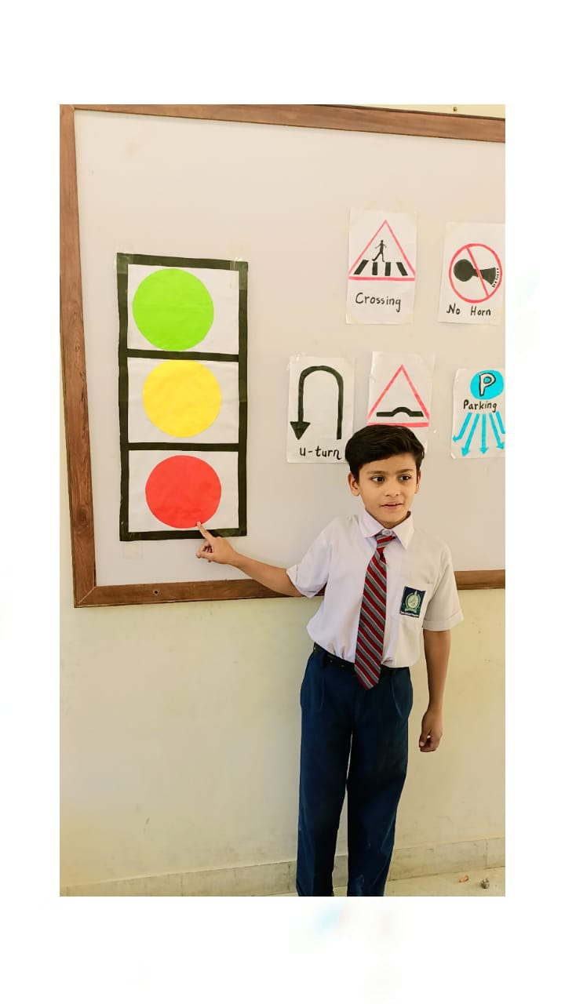
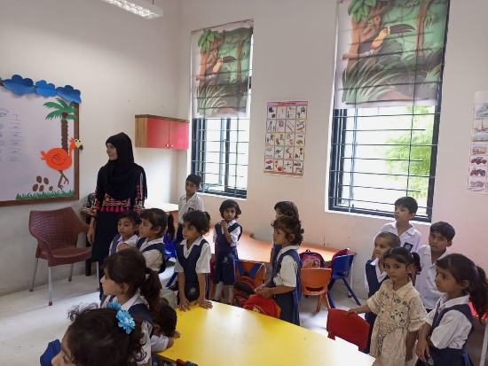
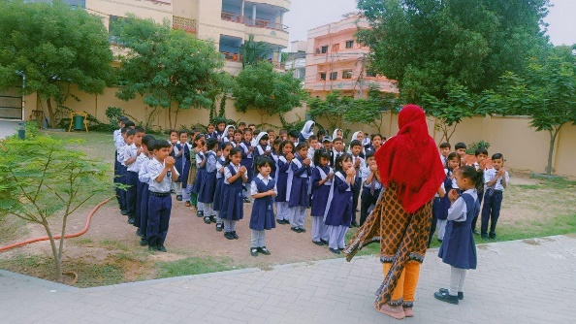
ECE-Level Two (Year 2022)
ECE – Level Three (Year 2024-25)
SMB Classes ECE-Level Three
SMB Journy from 2022-Present

- Orientations
- PTM
- Eid Milad-Un-Nabi
- Independence Day
- Color’s Day
- Season Day
- Health Screening Activities
- Culture Day
- Sports Day
- Table Manners
- Labour Day
- Plants Activities
- Eid Milan Parties
- Mango Day
- Winter Day
- Orange Day
- Back to School
- Movie Classes
- General Knowledge Classes Through Media
- Earth Day
- Iqbal Day
- Teachers Day
- Mother’s Day
- And Other Activities According to the Academic Calendar

